TRƯỜNG THCS PHAN CÔNG HỚN
TỔ TIẾNG ANH
TIẾNG ANH 6
TUẦN 26 (TỪ 10/03 ĐẾN 15/03)
PHIẾU TỰ HỌC
SỬA BÀI TẬP TUẦN 25
Lesson 1-1

II. Practice
Exercise 1/ Write the suitable word for each picture
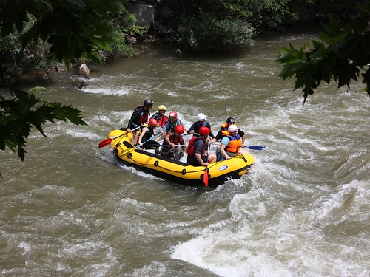
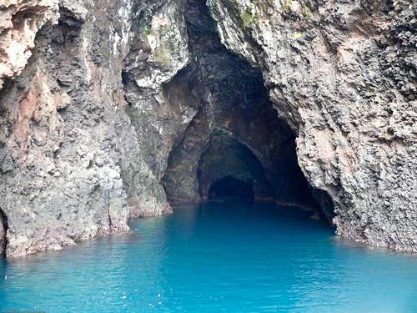
- _____rafting_ 2. _____cave___
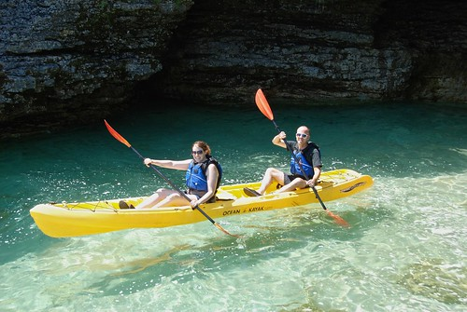
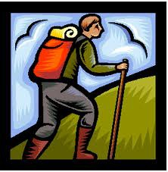

3._____rafting____ 4.______hiking_____
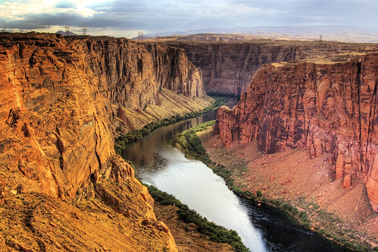
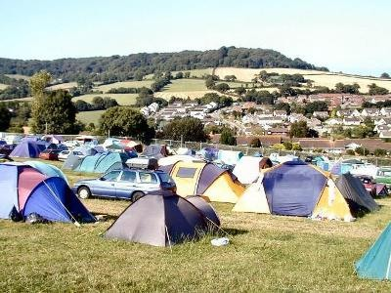

5.____canyon_____ 6.____campsite_____
Exercise 2/ Write the words to match with the correct descriptions:
1. the sport of traveling in a long, thin boat. _______kayaking_____
2. a low place between hills or mountains with a river going through it. _______canyon______
3. the activity of going for long walks. _______hiking________
4. the sport of traveling down a river in a rubber boat. _______rafting_________
5. a large hole on the side of a hill or under the ground. ______ cave_______
6. a place where people can put up a tent. ______ campsite _______

Lesson 1-2

II. Practice
Exercise 1/ Read the sentences. Underline the correct words.
1. You should/ shouldn’t visit Cat Tien National Park. It’s really beautiful.
2. We can go/ to go kayaking inside the caves.
3. Peter wants staying/ to stay at a hotel by the canyon.
4. Should we takes/ take the bus? There’s a bus station right next to the campsite.
5. We can’t go climb/ climbing today. The weather’s awful.

Exercise 2/ Read the mail about a vacation. Write one word for each blank.
Hi, Suzie,
How are you? Are you excited for our class camping trip?
I think we ___should______ go to Adventure Island.
We can ______go_______ hiking in the forest and kayaking in the bay.
It sounds great!
I think the Green Forest Caves sound quite interesting, too. But I have some more questions:
.What can we_______ do ________ there?
. I really want _____go______ rafting.
. How long does it take to get there?
. It takes about an hour, I guess.
. Also, what _____ should_________ we need to bring?
I’m very excited!
Speak to you soon.
Gemma

Lesson 1-3
A/ Pronunciation
I. Find the word that underlined part differs from the other three in pronunciation.
1. A. signing up B. hiking C. swimming D. climbing
2. A. rafting B. camping C. acting D. gaming
3. A. kayaking B. playing C. staying D. saying

II. Find the word that differs from the other three in the position of primary stress.
1. A. excited B. boring C. awful D. animated
2. A. campsite B. parade C. drama D. bottle
3. A. invader B. apartment C. canyon D. garage

B/ Practice
Exercise 1/ Put the words in the correct order to make correct sentences.
1. there / we / ?/ do / can / What /
What can we do there?
2. on/ Where/ go/ should/ our/ we/ trip/?/
Where should we go on our trip?
3. two/ takes/ by / It/ car/ ./ hours/
It takes two hours by cars.
4. at/ by/ I/ to/ a/ want/ campsite/ river/ stay/./ the/
I want to stay at a campsite by the river.

Exercise 2 / Read the situations. Use “ should/ shouldn’t ” to give advice.
1. There’s a drama on at the movie theater tonight.
You should watch the drama on the movie theater tonight.
2. Our environment is terribly polluted.
We should protect our environment.
3. My mom wants to buy a sweater.
She should go shopping.

Exercise 3/ Name some activities that you can do on a trip .
1. rafting | 2. hiking
3. kayaking | 4. climbing
5. reading | 6. camping
7. cooking | 8. swimming
9. taking photographs | 10. playing games

